<https://cucumber.io/tools/cucumberstudio/>

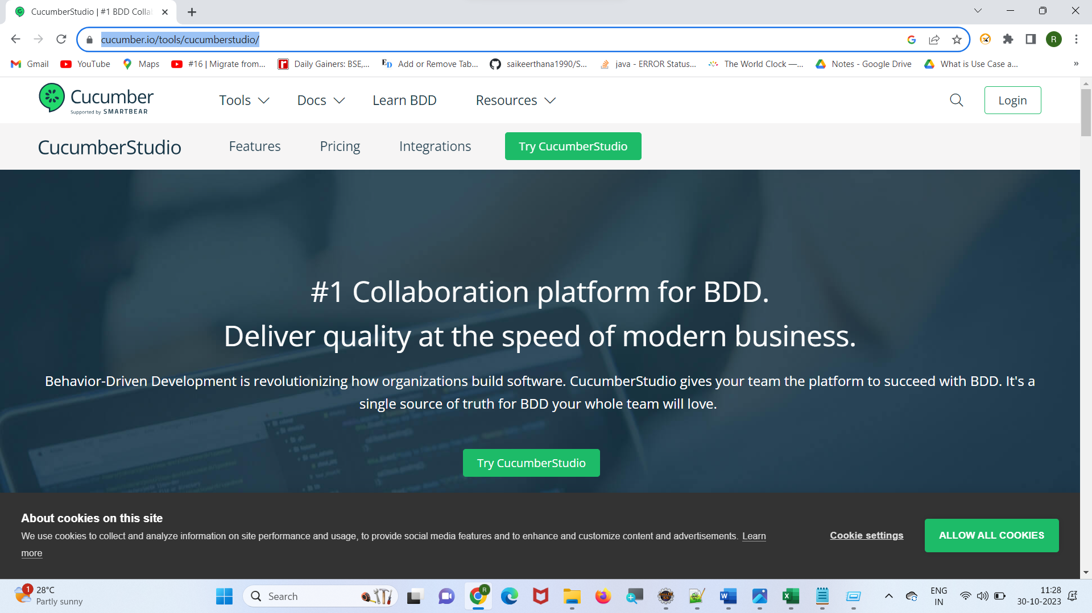

Click on “Try Cucumber studio”

Fill the below form

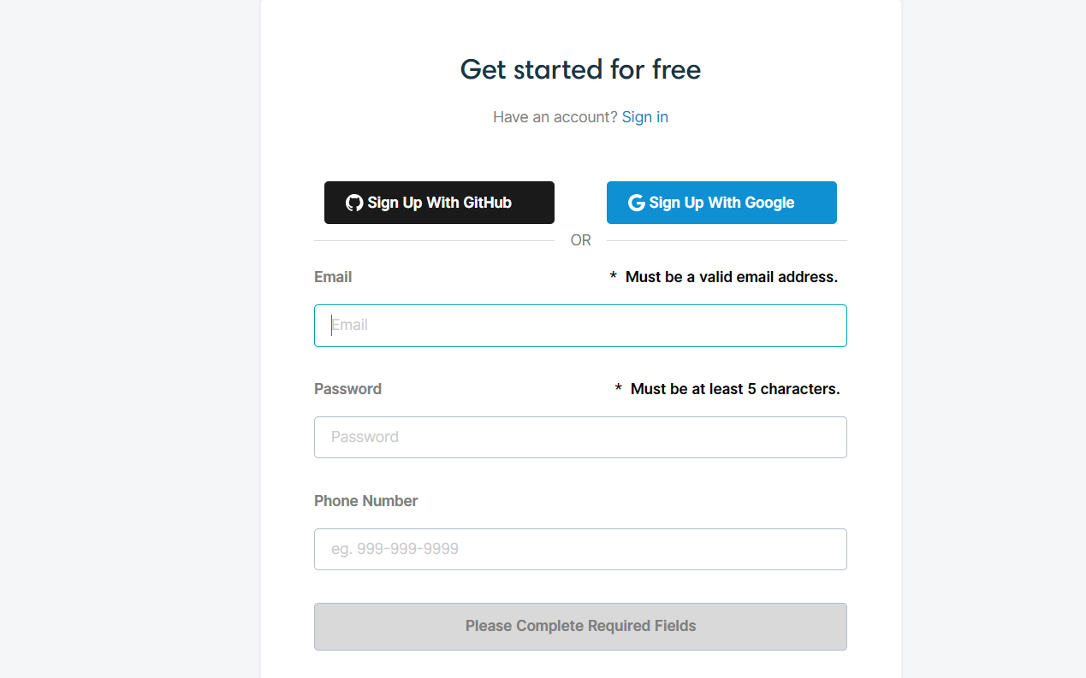

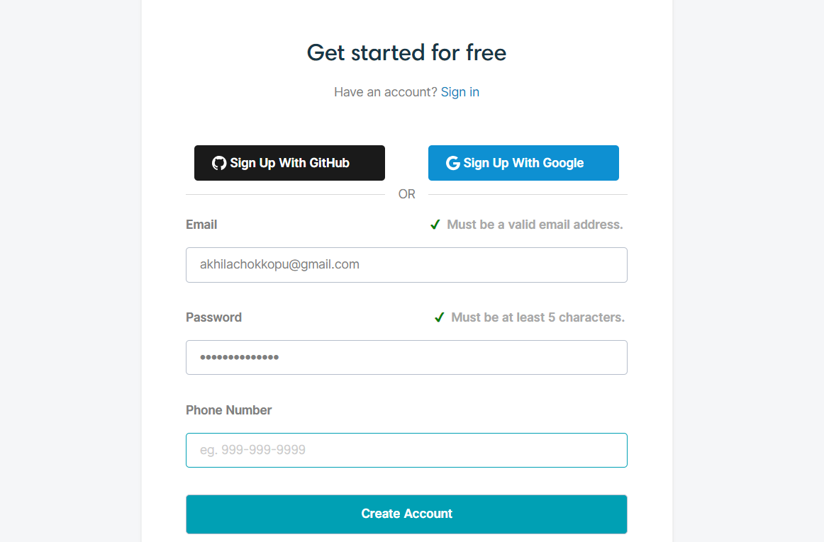

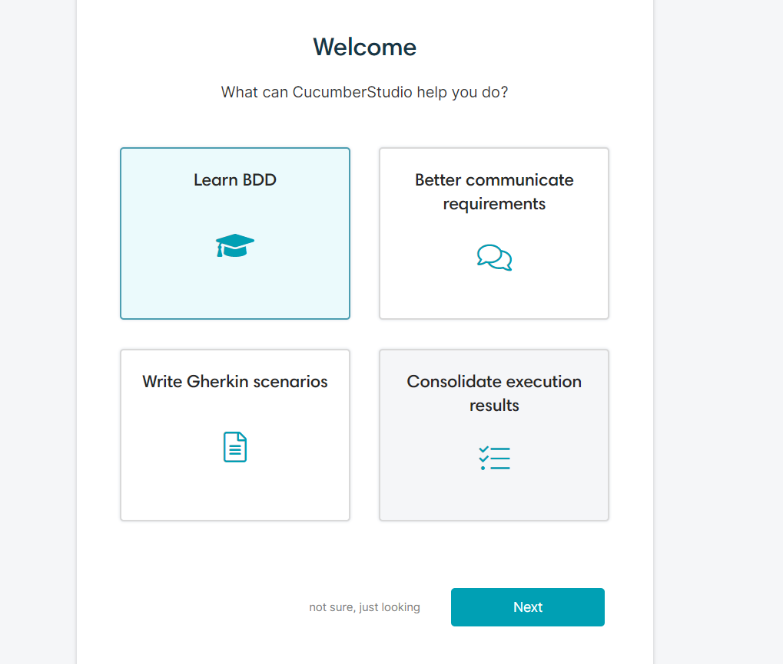

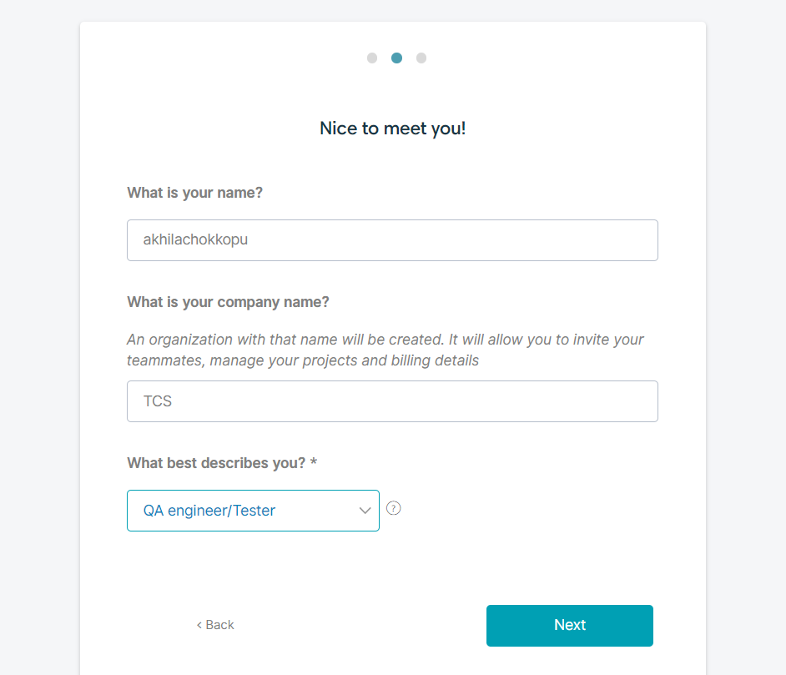

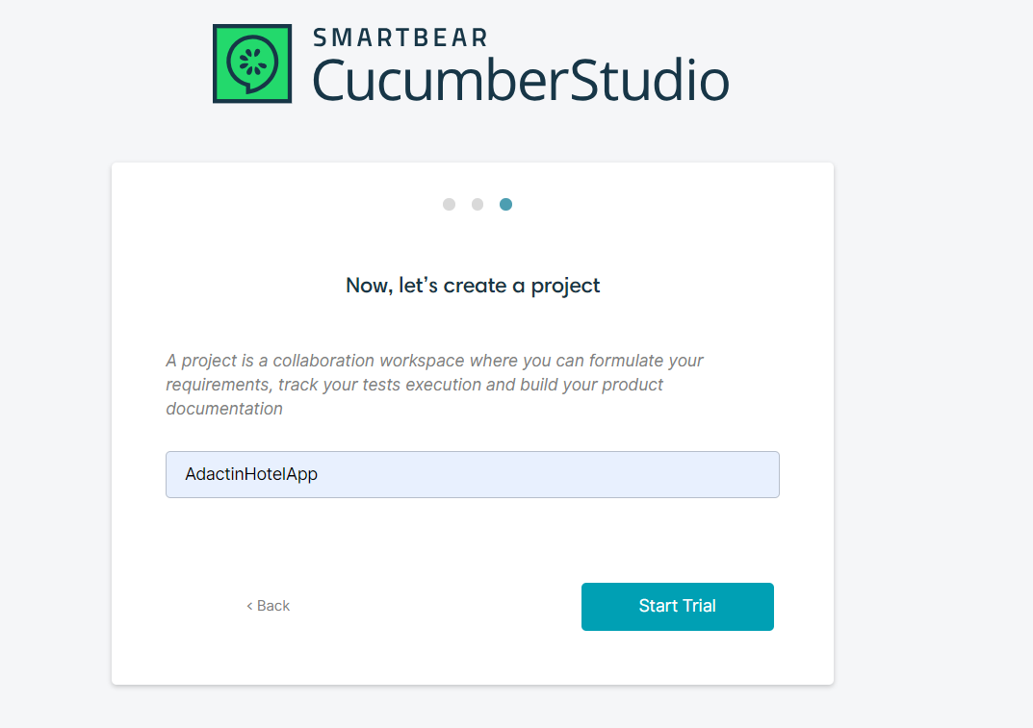

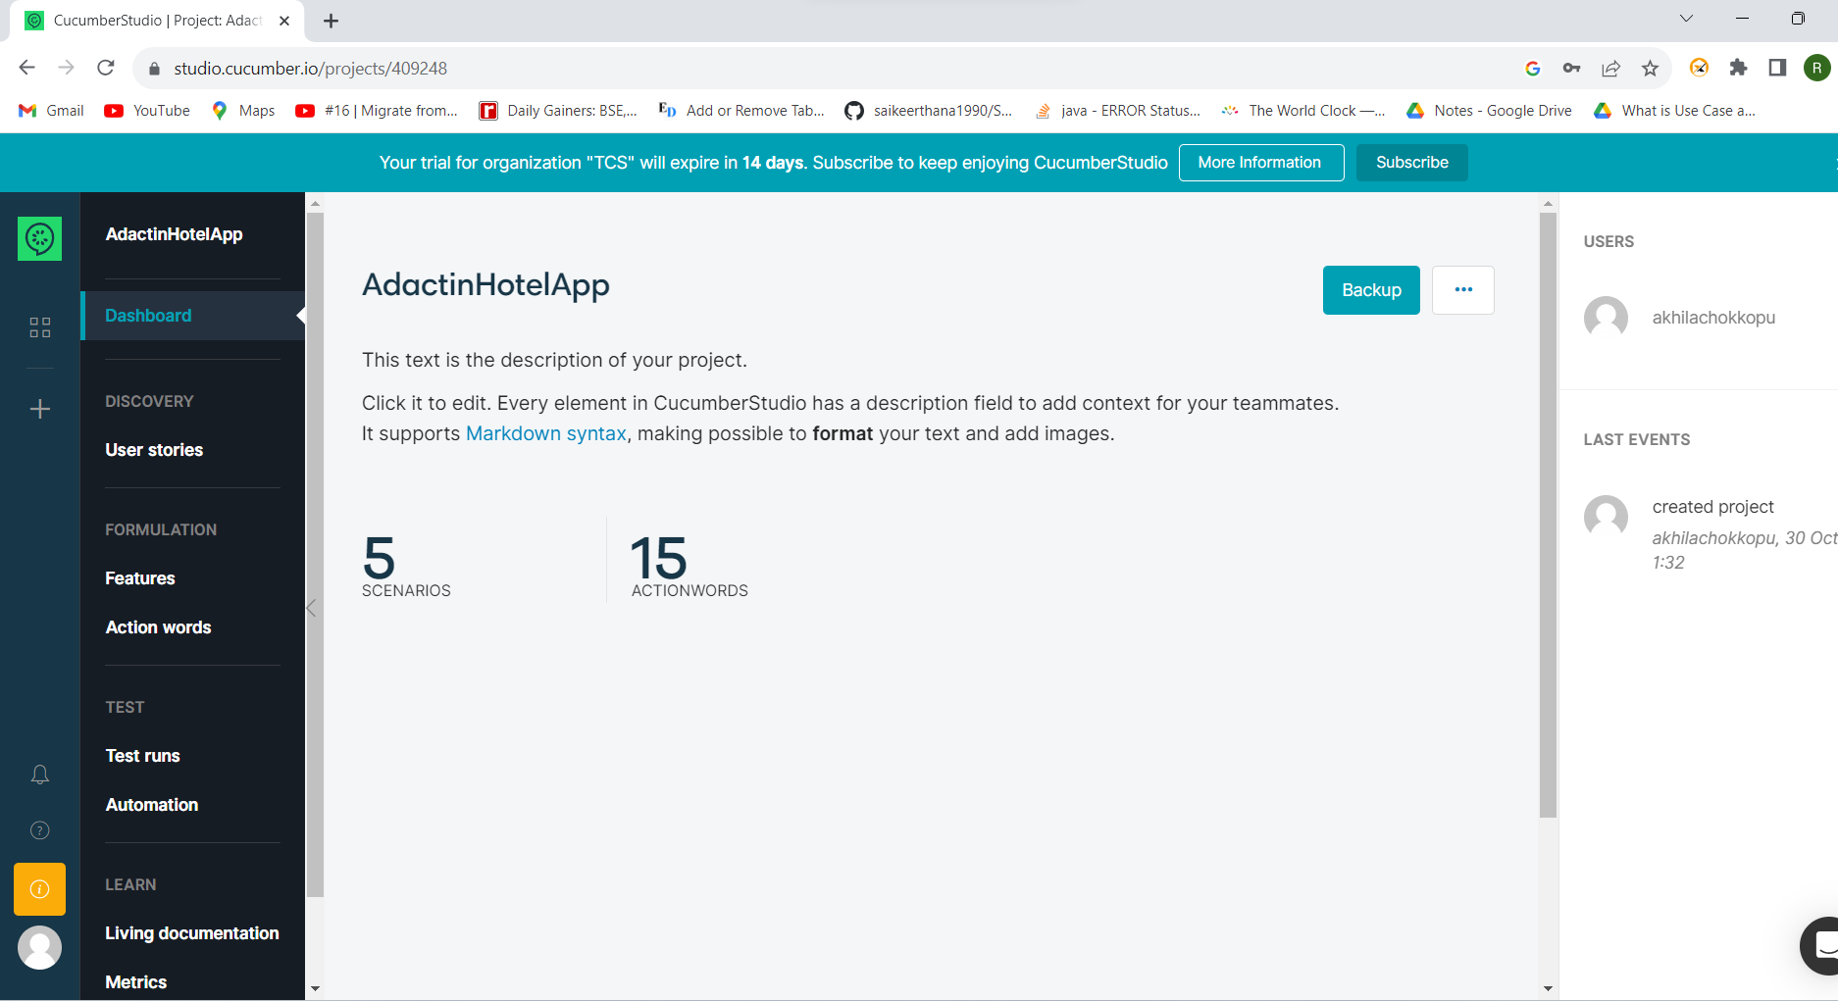

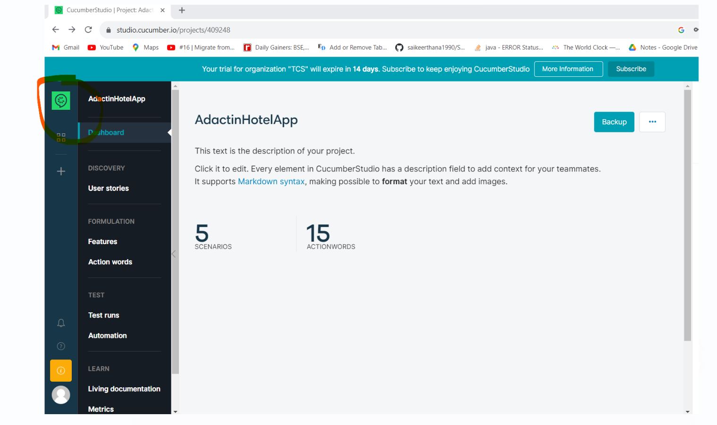

Click on below project :

“Testing BOOKSTORE application (sample N°1)”

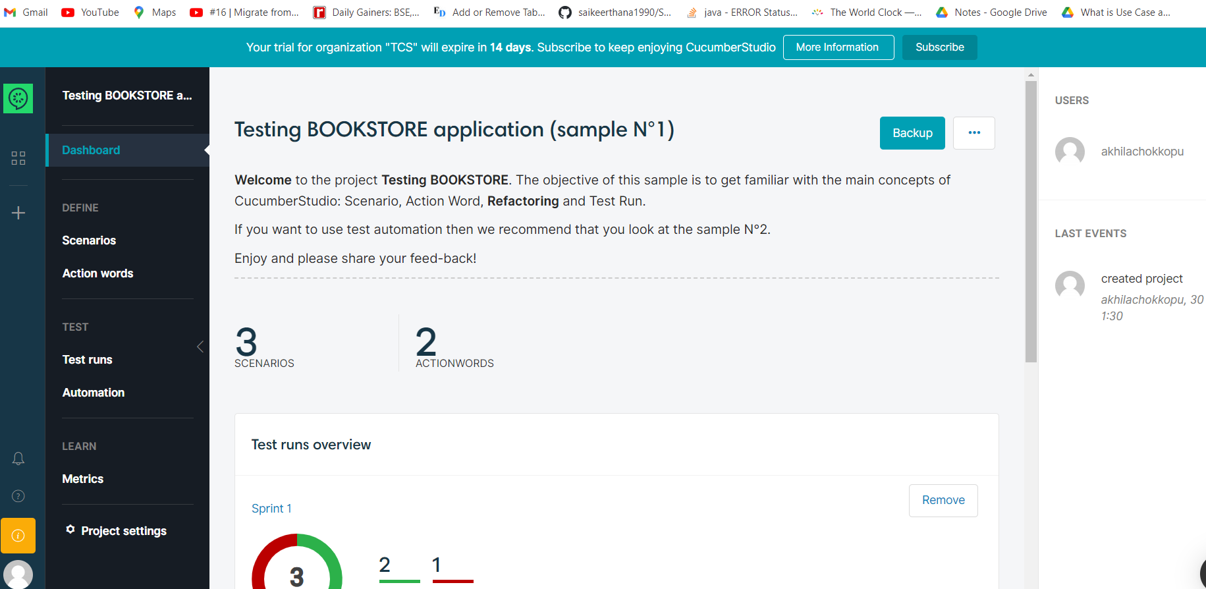

Click on … 🡺 click on Delete🡺 Delete Project

Same for “Testing CASH WITHDRAWAL (sample N°2)”

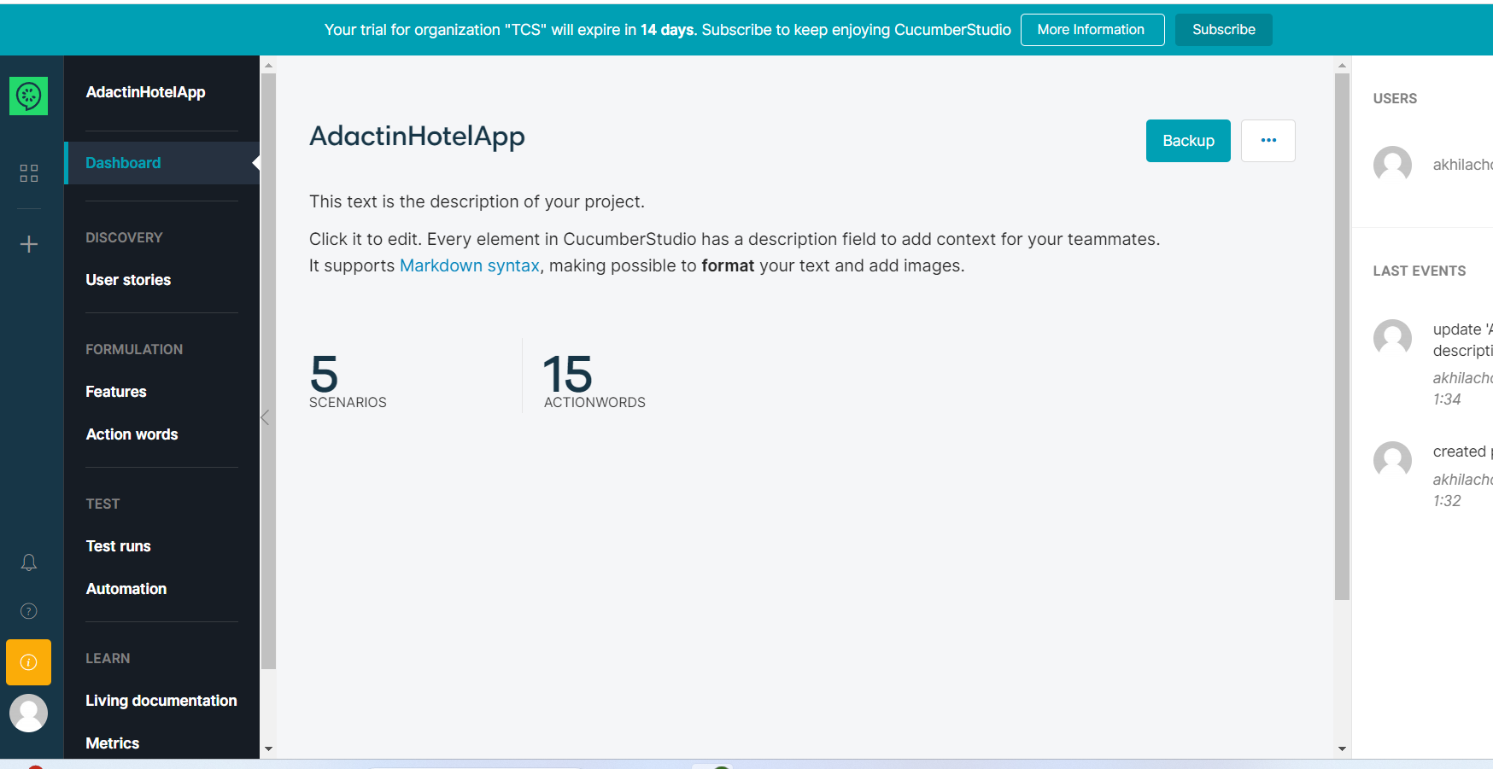

Now you see AdactinHotelApp project

How to write test cases ?

Click on “Feature”

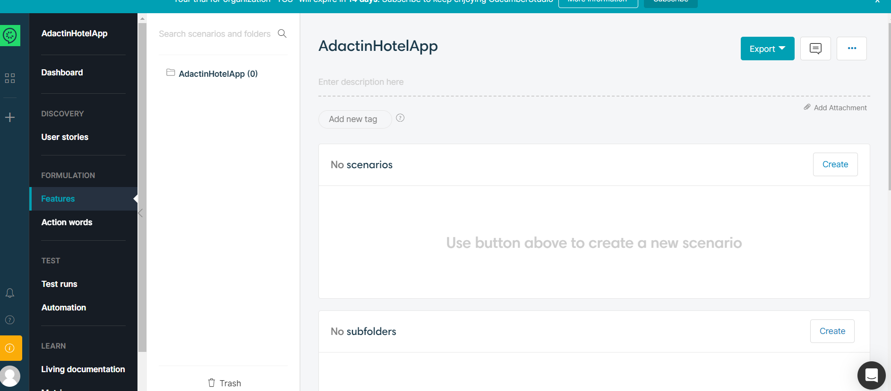

Click on “Create” next to No subfolders

And click create

Give some folder name like Login_Functionality

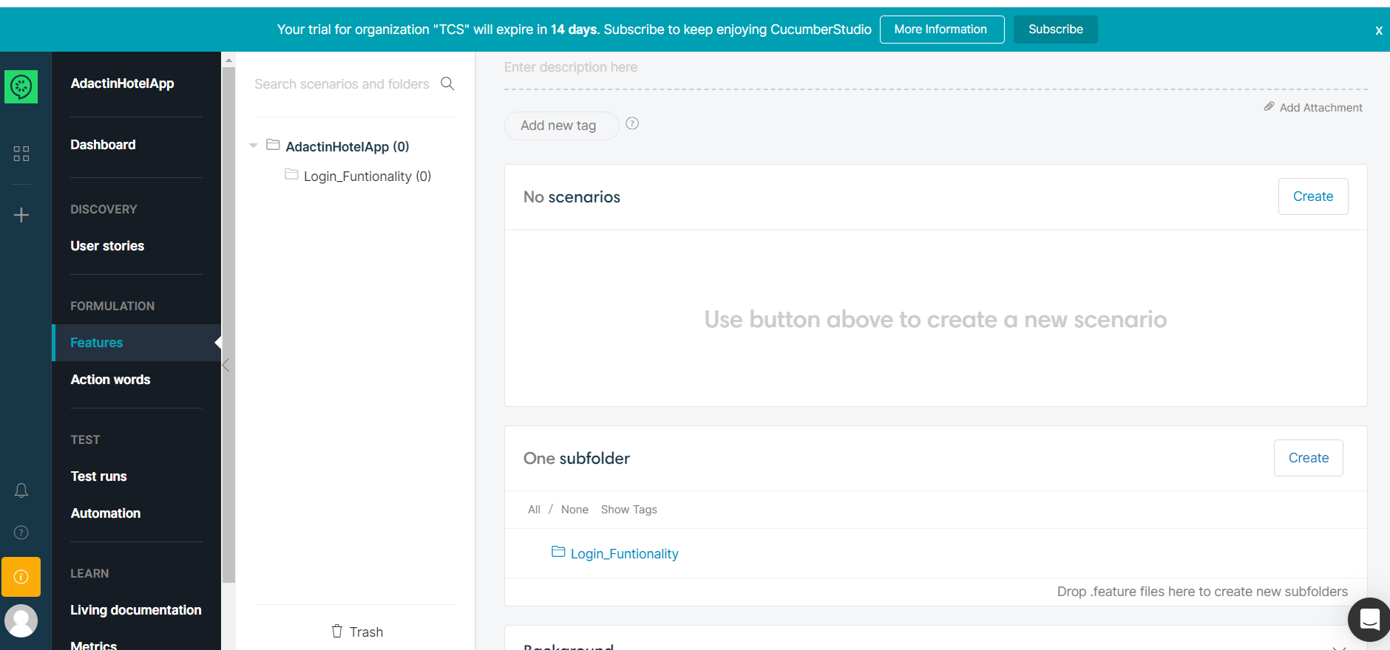

No click on create next t No Scenario

Give some scenario name (like Login using valid credentials) and click create

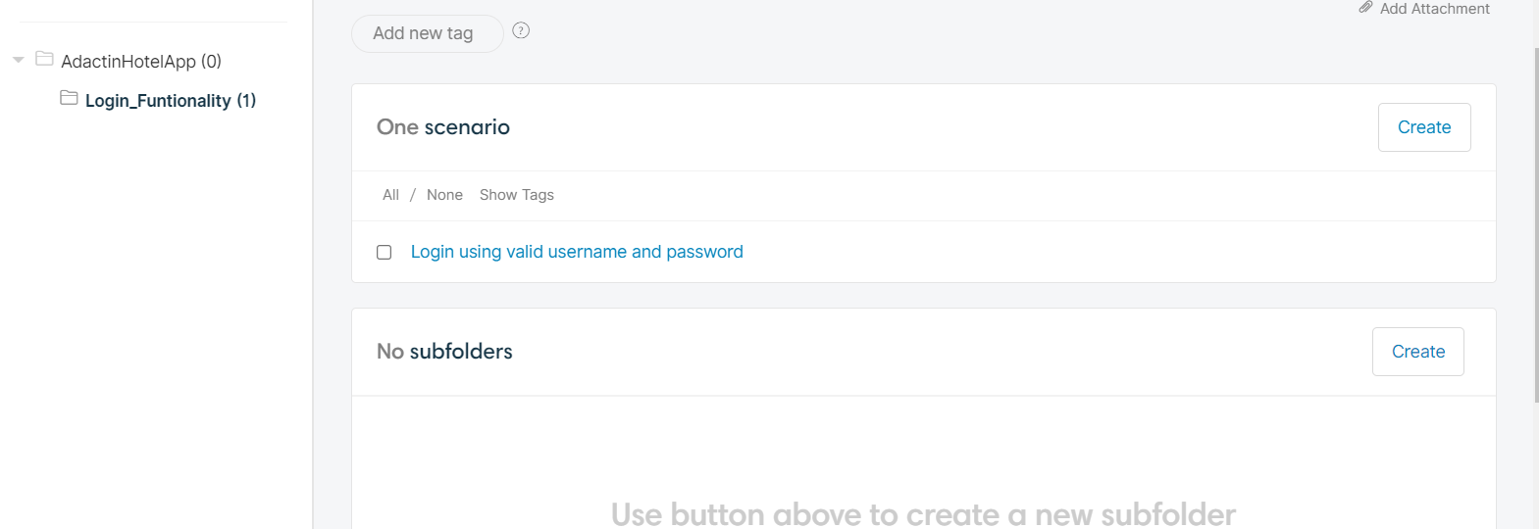

#Author: your.email@your.domain.com

#Keywords Summary :

#Feature: List of scenarios.

#Scenario: Business rule through list of steps with arguments.

#Given: Some precondition step

#When: Some key actions

#Then: To observe outcomes or validation

#And,But: To enumerate more Given,When,Then steps

#Scenario Outline: List of steps for data-driven as an Examples and <placeholder>

#Examples: Container for s table

#Background: List of steps run before each of the scenarios

#""" (Doc Strings)

#| (Data Tables)

#@ (Tags/Labels):To group Scenarios

#<> (placeholder)

#""

## (Comments)

#Sample Feature Definition Template

@tag

Feature: Title of your feature

I want to use this template for my feature file

@tag1

Scenario: Title of your scenario

Given I want to write a step with precondition

And some other precondition

When I complete action

And some other action

And yet another action

Then I validate the outcomes

And check more outcomes

@tag2

Scenario Outline: Title of your scenario outline

Given I want to write a step with <name>

When I check for the <value> in step

Then I verify the <status> in step

Examples:

| name | value | status |

| name1 | 5 | success |

| name2 | 7 | Fail |